Autodesk Fusion 360 Sign-Up Process
Follow this link to begin: Sign-Up

Click the ‘Get Started Button’… | 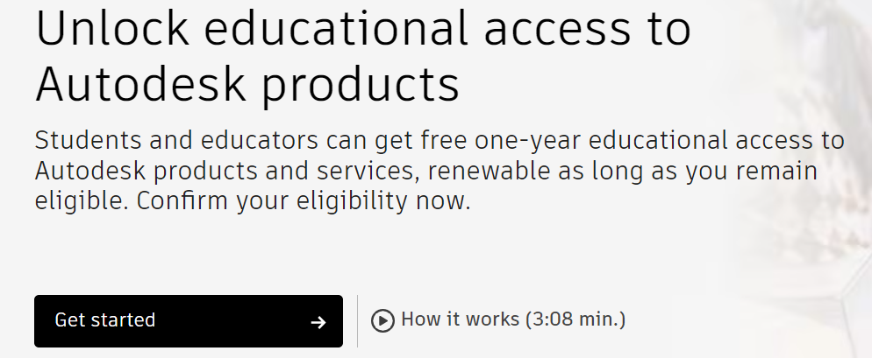
Use the dropdown menu to select ‘Student’ | 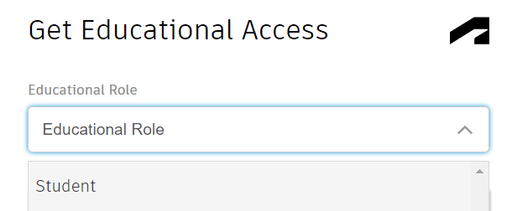
Enter Birth Date…  - Only uses correct year, do not use correct day/month | 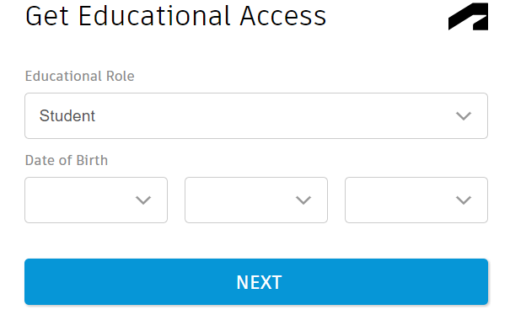
Enter your information…  - Your name must match the student proof document you will be given  - Your email is your student#@learn71.ca  - For your password to be accepted it must follow the criteria shown | 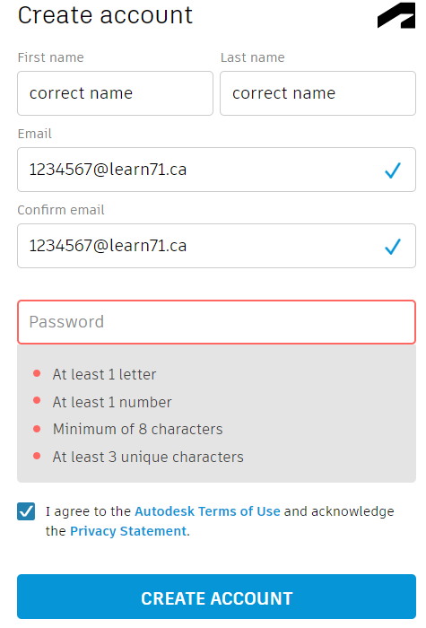
You will need to sign into your school district email, find the email from Autodesk and click on the ‘Verify’ button. | 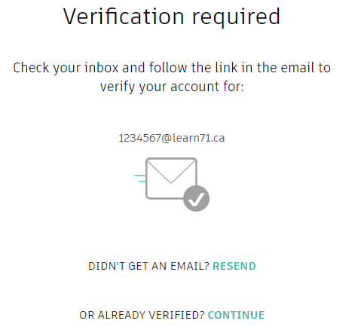
Again, click this link: Sign-Up
You once again see the ‘Get Started’ button, but it should now be white. Click it… | Should be white!
You will now be asked to check over the information that they have for your account. It should be fine as you just entered it.  - If all looks good select ‘Confirm’ | 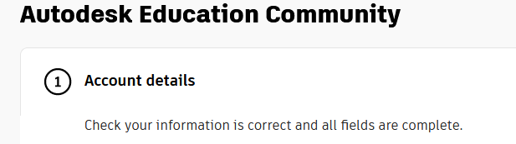  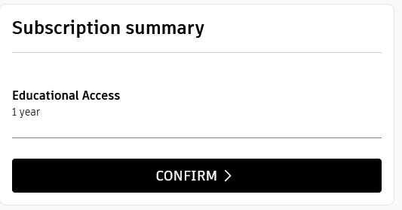
You are now being asked for a document that proves you’re a student.  - Click the ‘Drag documents here’ box  - Navigate to the location of the document:  - This PC > (H:) SchoolShare > Maker Wood Studenz > Your class > Schedules  - Double click the document with your name  - You should now see the file name & size below the drag docs box. Click ‘Submit’ | 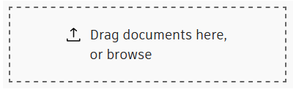  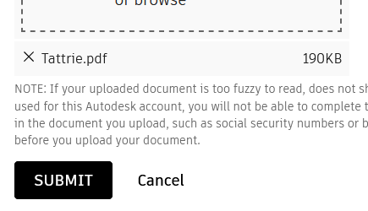
Don’t press the ‘Close’ button on the next screen, just wait a bit. A ‘ Congratulations’ message will appear.
Almost there. When the Congrats message appears call you teach over for the final steps.

