END TABLE PROCEDURE

Name: ___________________

Leg Procedure

1) Break out stock for the legs (Rough sizes)

Square legs _____ pieces _____ thick, by ________ wide, by _______ long
OR
L-shaped _____ pieces _____ thick, by ________ wide, by _______ long
_____ pieces _____ thick, by ________ wide, by ______ long

2) Cut to rough length on mitre saw of ___________ long

3) Rip to rough width on table saw of ______________ wide and _____________ wide

4) I should now have _________ pieces that are __________ wide by ________ long
and ___________ that are ____________ wide by _____________ long.
- write your name on the end of each piece in pen

5) Joint a face size on all the pieces - mark them

6) Joint a face edge on all the pieces - mark them

7) Plane all pieces to _________ thickness

8) 45⁰ L-SHAPED LEGS ONLY - Rip to final width of _________ wide
NON 45⁰ L-SHAPED LEGS - Rip to final width of _________ wide and _________ wide

9) L-shaped legs ONLY or if gluing to make square legs Glue and clamp each leg
- 3 bar clamps or C-clamps if gluing square, or L-shape legs
- 3 web clamps if gluing 45⁰ L-shape legs. Glue two at a time

10) Scrape off excess glue
- use a chisel

11) SQUARE LEGS ONLY - Joint one edge only on all 4 pieces and mark it.
- make sure the face side is against the fence

12) SQUARE LEGS ONLY - Plane to thickness of ________ thick
- the legs should now be __________ by __________ thick

13) Cut one end square using the mitre saw

14) Cut to final length of _____________ long using the mitre saw
Rail Procedure

1) Break out stock (Rough size)

SQUARE TABLE 4 pieces _______ thick, by ______ wide by _________ long
OR
RECTANGLE 2 pieces _____ thick, by ______ wide by _________ long
2 pieces _____ thick, by ______ wide by _________ long

2) Cut to rough length on mitre saw of ___________ long and ____________ long

3) Rip to rough width on table saw of __________ wide

4) I should now have __________ pieces that are __________ wide by ________ long
and. _______ pieces that are __________ wide by ________ long
- write your name on the end of each piece in pen

5) Joint face side and face edge on all pieces and mark them

6) Plane all pieces to ¾” thickness

7) Rip to final width of _______________ wide

8) Cut one end square using the mitre saw

9) Cut to final length of ____________ long and ___________ long using the mitre saw

Dowel pin layout

1) Set your table upside down with the rails and legs in position. Hide any defects or cracks by putting the poor sides of the legs and rails to the inside. Get a web clamp and tighten it up around the table. Flip the table right side up.
label the legs and rails from the top as shown in the diagram (A-H)
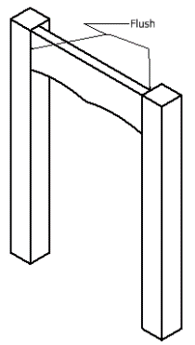
line up the top edges on all the legs and rails
line up the rails flush to the outside on the legs
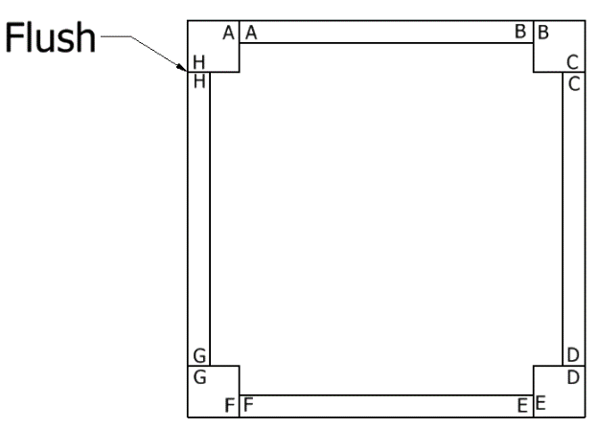
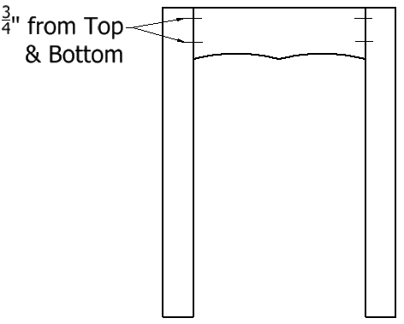
2) With the tables clamped, measure down
from the top of the rails 3/4" or 20mm on the outside all the way around the table

Place a pencil mark across the legs and rail

3) Measure up 3/4" or 20mm from the bottom of the rail all the way around the table - place a pencil mark across the legs and rail

- HAVE THE TEACHER CHECK IT

5) Get a dowel jig from the teacher and set it up to drill the holes in the rails

6) Clamp it to the end of your rail
- line it up with the pencil marks you made in step 2 and 3

7) Drill the hole - move the drill up and down to prevent the drill bit from clogging

8) Repeat steps 6 - 7 for the remaining holes

9) Drill the holes in the legs.

10) Clamp it to the side of your leg
- line it up with the pencil marks you made in step 2 and 3

11) HAVE THE TEACHER CHECK IT BEFORE YOU DRILL

12) Drill the hole
- move the drill up and down to prevent the drill bit from clogging
- repeat for the remaining legs

- Router the legs and/or rails if necessary

14) Sand the legs and rails with 80, 120, 180 and 220 grits before you assemble
- it easier now then later

Table Leg/Rail Assembly Procedure
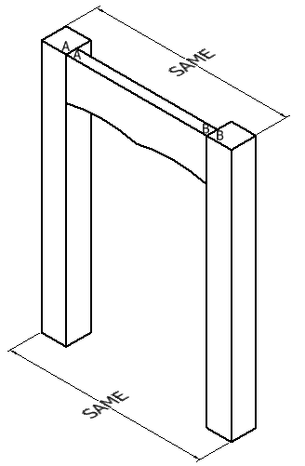
- Get 8 dowel pins from the teacher

- apply glue to the dowel pins one at a time and insert them into the rails labeled A/B and E/F. Then apply glue to the holes in the legs labeled A/B and E/F.

- match up the labeling on two legs and a rail and connect the two together

- clamp the legs and rail together with one or two
bar clamps

- make sure the legs are parallel as follows

- When the two sets of legs/rail (A/B and E/F) have dried get another 8 dowel pins and glue the remaining two rails (C/D and G/H) in place.

3) Tidy up any badly aligned joints with a hand plane

4 Piece Top Procedure

1) Break out stock for the top (Rough sizes)
Square 4 pieces ________ thick by ________ wide by _______ long
OR
Rectangle 2 pieces ________ thick by ________ wide by _______ long and
2 pieces ________ thick by ________ wide by _______ long

2) Cut to rough length on mitre saw of ___________ long and ___________ long

3) Rip to rough width on table saw of __________ wide

4) I should now have __________ pieces that are __________ wide by ________ long and __________ pieces that are __________ wide by ________ long

5) Joint a face side and face edge on all of the pieces - mark them.

6) Plane all pieces to ¾” thickness

- Rip to final width of _______________ wide

- Cut one end on a 45⁰ angle of all 4 pieces

- Cut to final length on a 45⁰ angle of ___________ and ____________ long

10) Using the router cut the rabbit for your wood, glass, etc. to fit into.

My rabbit is ___________ wide by ____________ deep.

11) Biscuit joint the ends of all 4 pieces.

12) Glue top together using a web clamp making sure the top is flat
insert biscuits into the slots

13) Sand to 80 grit

14) Router the outside edge of the top

15) Sand to 220 grit

Solid Top Procedure

1) Break out stock for the top (Rough sizes)
______ pieces _______ thick by __________ wide by _________ long

2) Cut to rough length on mitre saw of ___________ long

3) Rip to rough width on the table saw of __________ wide

4) I should now have __________ pieces that are __________ wide by ________ long.

5) Joint a face side and face edge on all of the pieces - mark them.

6) Rip to final width of __________ wide plus 1/16” (1mm)

7) Re-joint the table-sawn edge ONCE

- Glue the pieces together in two sections as illustrated
make sure the face side is down and FLUSH when gluing
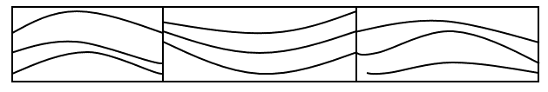
- Scrap off the glue

10) Re-joint a face side if possible – only if they sections are less than 8”

11) Plane to thickness of ___________

12) Glue the two top pieces together
- make sure they are even.

- Cut one end square on the table saw

- Cut to final length of __________ on the table saw

- Sand to 220 grit

Final Assembly Procedure

- Place TOP (good side down) on the workbench. Make sure the workbench is free of anything that could scratch the top.

- Place bottom part (leg/rails) onto the top and centre it from all 4 sides.

- Insert #8 - 1 ¼” screws through cleats and screw pieces together.

4) Stain project 3 times, then satin wax 1 coat.

